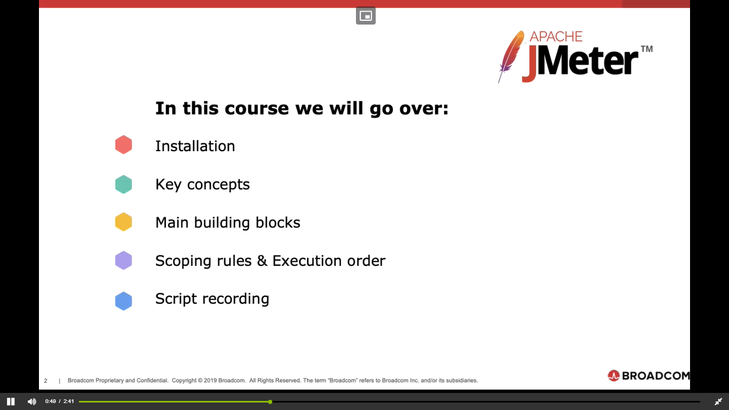
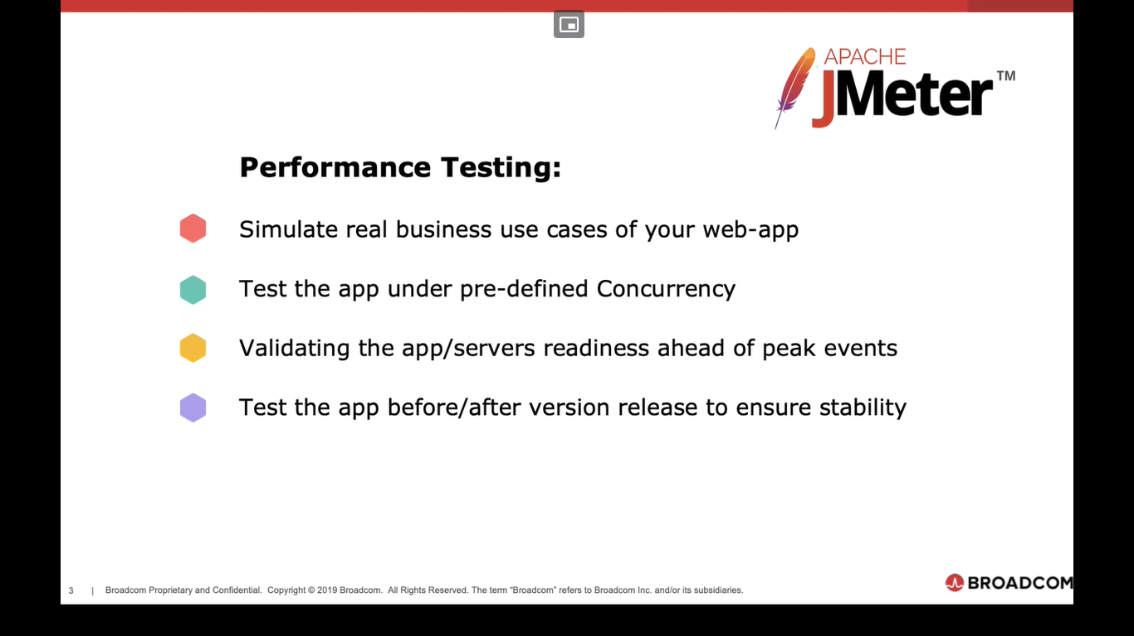
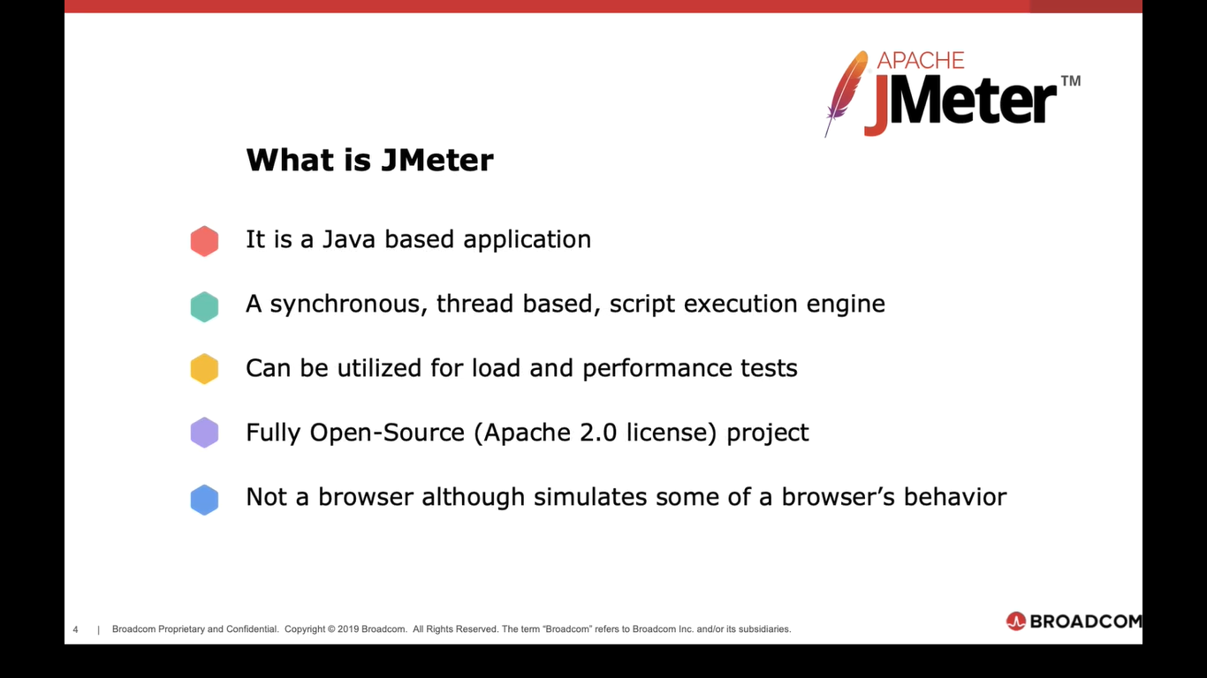
Since Jmeter 4, installation of Java 8 or 9 is recommended.
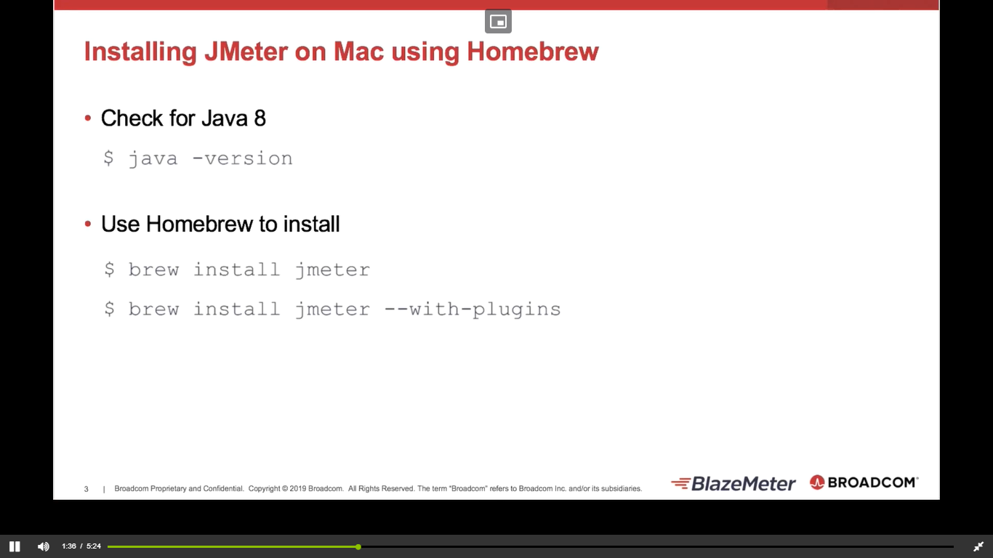

Jmeter folder structure
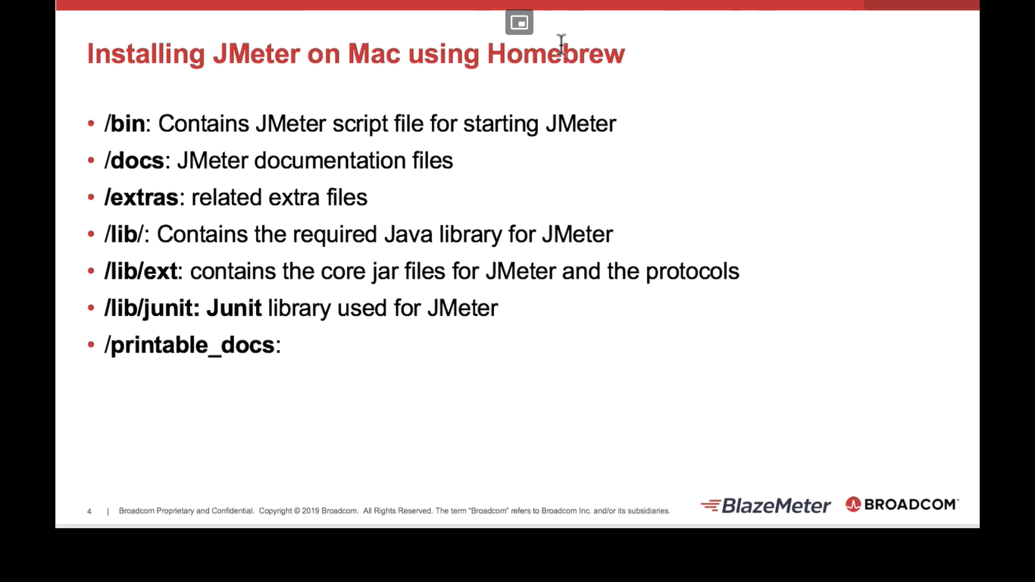
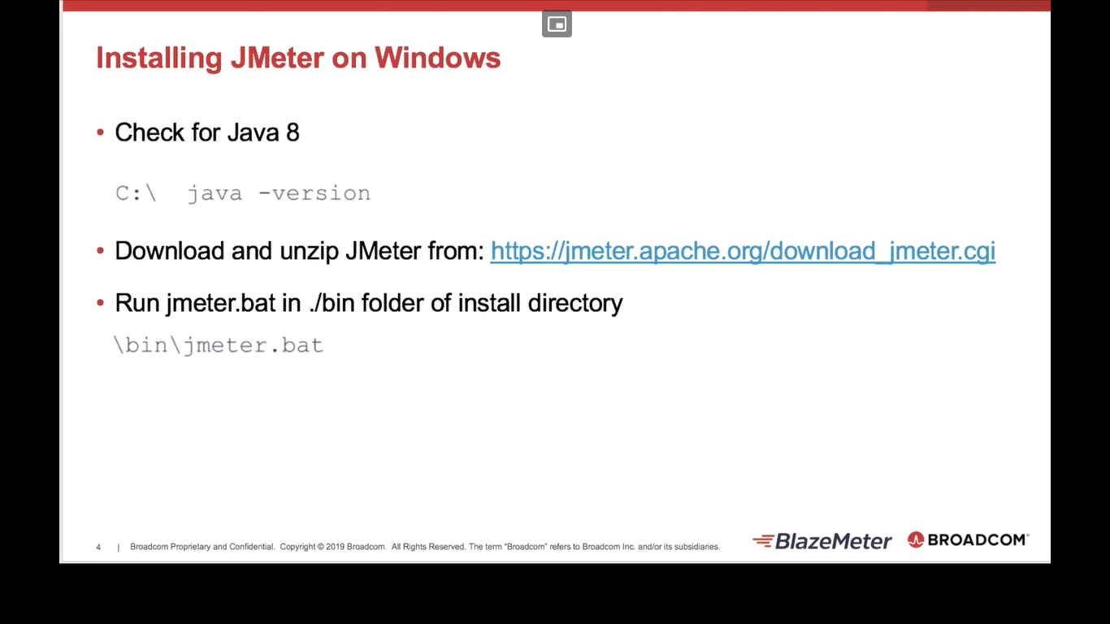
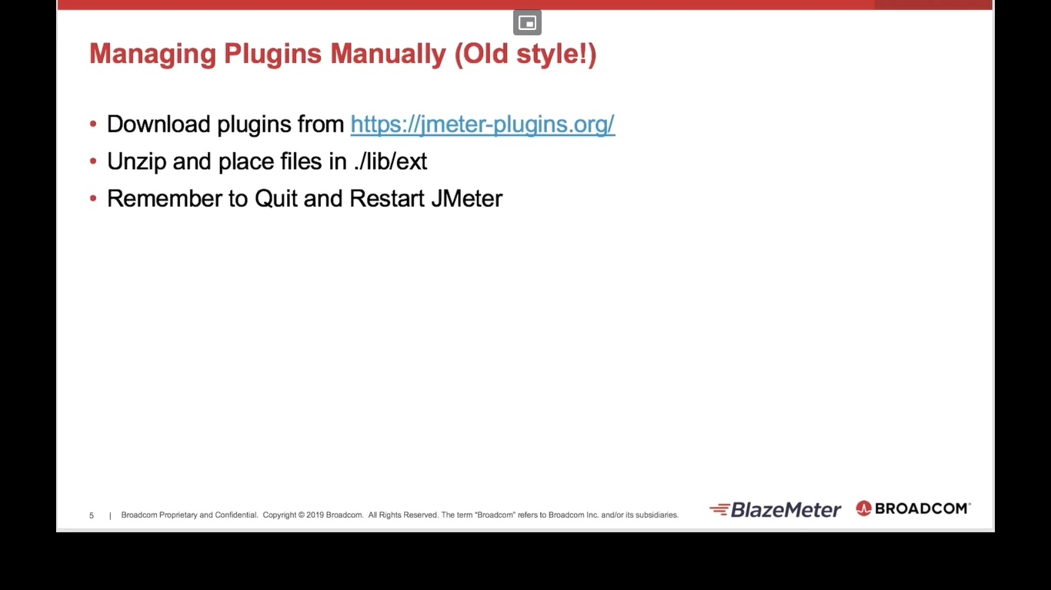
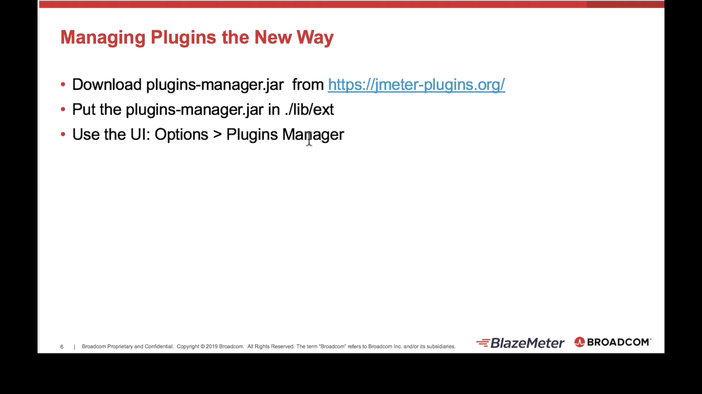
The plugins manager option will be available only after we paste the plugins-manager jar in the ext folder correctly
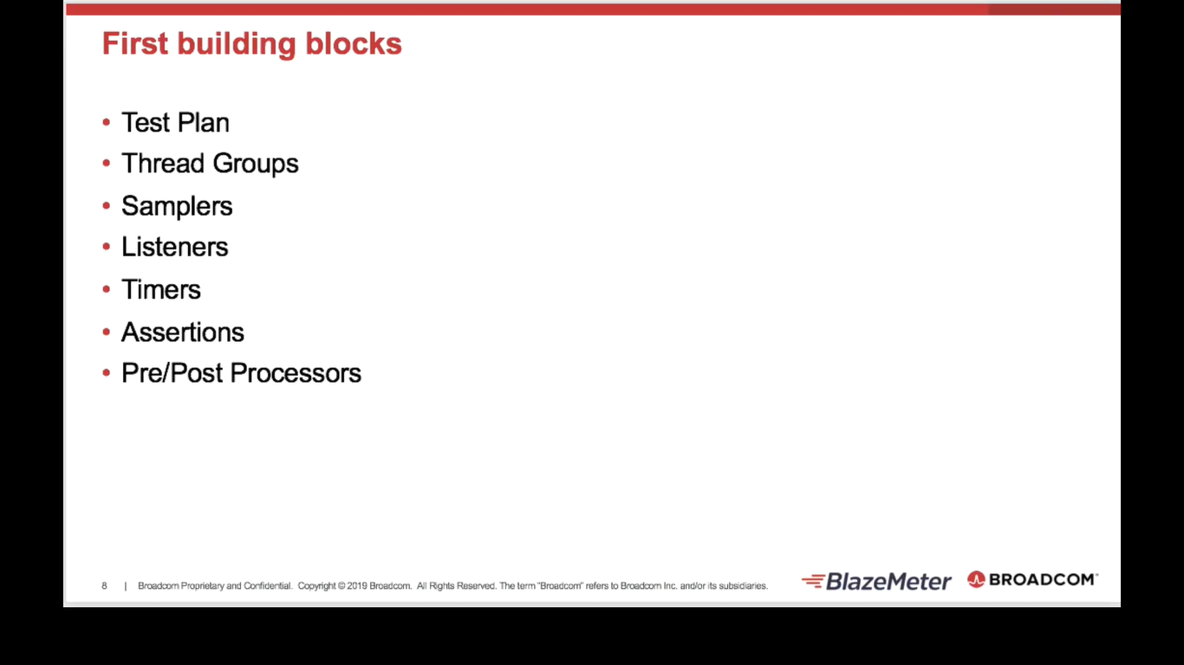
Test plan – root of the entire jmeter suite
Start by adding thread group to the test plan
Thread group is for configuring the no.of threads (users) , ramp up period and iterations
Sampler allows jmeter to send different types of requests to a server. It controls the traffic
RC on thread group add sampler (HTTP request)
In sampler we have to specify which server we are going to hit (eg: demoblaze.com)
Timer – used to introduce intentional delay or pause in the tests
RC on thread group add Timer (Constant timer), value – 300ms
Timer will always be executed before the sampler (HTTP req)
RC on thread group add Assertion (Response assertion)
Select field to test
RC on thread group add preprocessor and postprocessor
Preprocessor are elements in jmeter that are used to execute actions before the sampler req is executed
Can be used for fetching data from DB, setting a timer before sampler exec or test data gen
postprocessor are elements in jmeter that are used to execute actions after the sampler req is executed
Can be used for asserting responses
Add JSR223 for pre and post processor
Listeners are jmeter elements that display test results
Commonly used elements in thread group
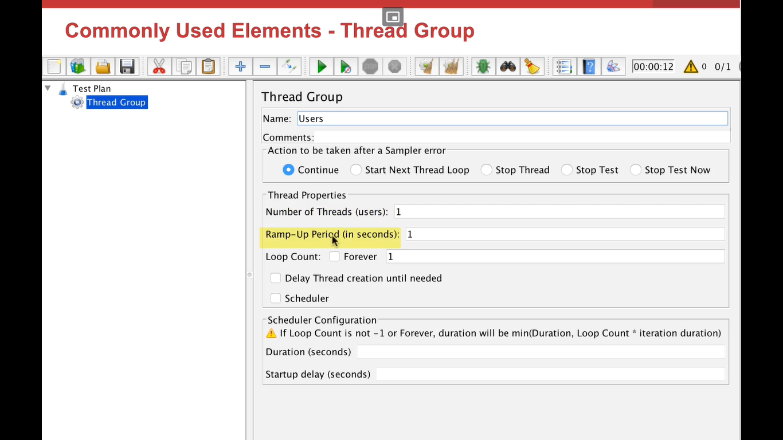
Ramp up period: time taken for number of threads specified to be active
Eg: ramp up – 20 sec, number of threads – 10, 20/10 = for every 2 sec, the thread count will increase and reach 10 ultimately
Scheduler- checked and duration 60 sec will run the tests in loop for 60 sec
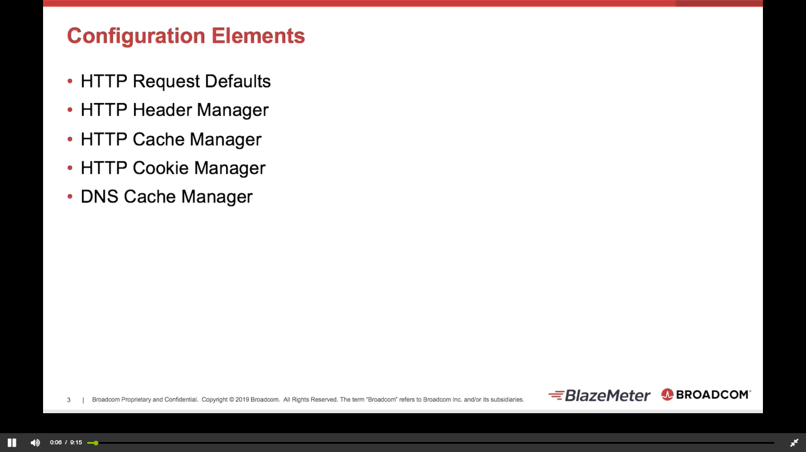
RC on test plan add config elements HTTP req defaults
Use of Config elements to remove duplicates and make the test plan more maintainable
Add view results tree listener
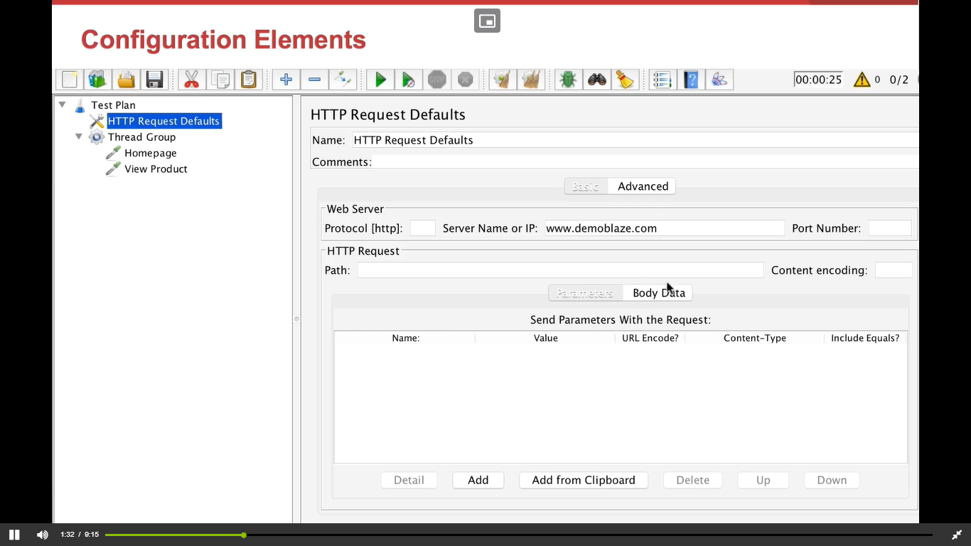
HTTP header manager helps us in adding/ overwriting the header
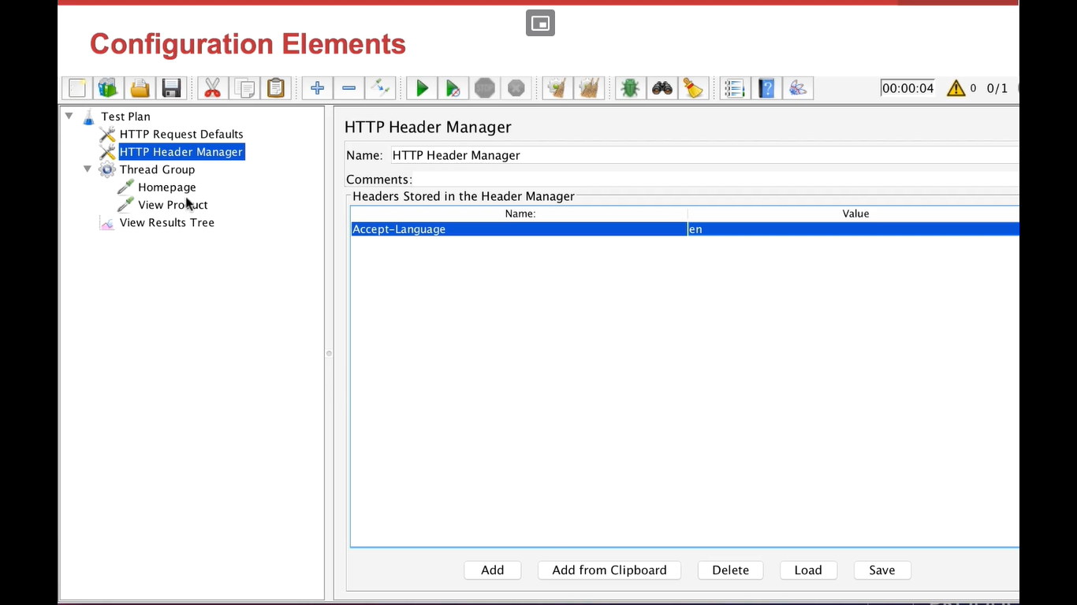
Request caching helps in reducing the traffic to the site, as it already stores few data when the first request hits
